The Soccer Player’s Diet
(Taken from “How to Eat for Soccer Peak Performance)

A typical western diet contains too much fat and not enough healthy, whole
grain carbohydrates. Soccer players should aim to make 60-65% of their diet carbohydrate, with an emphasis on fresh fruit and whole grains such as brown rice and pasta, wholemeal bread, potatoes and high fibre cereals. About 20-25% of total calories should be in the form of fat. The majority of this should be in the form of good fats (monounsaturated, polyunsaturated, omega fatty acids) found in oily fish like mackerel and salmon, olive oil, avocado and raw nuts (not roasted or salted). Protein should make up the remaining 10-15% of a soccer player’s diet derived from fish, poultry, low fat milk and lean red meat for example.

Here’s a sample day’s eating plan:

Sample Day’s Diet for a Soccer Player in Training

Breakfast Piece of fruit
Bowl of oatmeal or porridge (sweeten with dried fruit or honey)
3-4 slices wholemeal bread toasted with small amount of butter/olive oil spread, jelly/jam
Glass of fresh fruit juice (not concentrated)

Snack Piece of fresh fruit
Plain yoghurt
2-3 fig biscuits/cookies

Lunch Tuna or grilled chicken
Bagel, baguette etc. (preferably wholemeal)
Mixed salad with olive oil and lemon juice dressing
Glass fresh fruit juice or low fat milk
Low fat or bran muffin
1-2 bananas

Snack Bag of nuts and raisins (such as almonds, pecans, Hazelnuts etc)
Dinner Large serving rice or pasta
Tomato sauce
Grilled fish, chicken or lean beef mince
Large mixed vegetable salad with dressing
Small serving of ice cream and strawberries

This is one sample day only and a wide range of foods should be eaten. Try
also to drink 2 litres (68 oz) water each day (fluids as part of a sports drink
count).

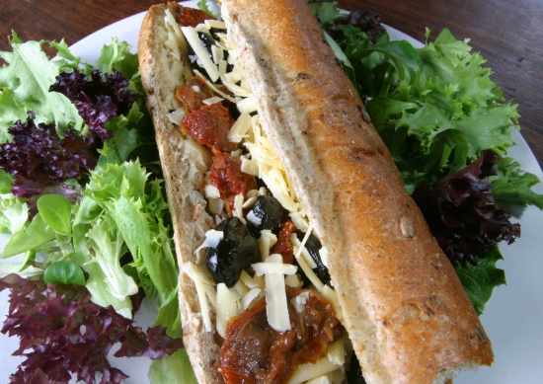
Pre Match Eating

The goal prior to a game is to maximize carbohydrate stores in the muscles and liver and to top up blood glucose stores. Studies have shown that consuming foods with a high GI within an hour of exercise can actually lower blood glucose, which is not what a player wants! The reason is because the body produces an "overshoot" of insulin, which helps muscles to take up sugar in the blood. This in turn causes low blood sugar levels.

Soccer players should eat foods with a low to medium GI before a match. This allows for a relatively slow release of glucose into the blood and avoids the unwanted insulin surge.

Consuming carbohydrate at least an hour before kick off allows any hormonal
imbalance to return to normal. Example low GI foods include pasta, whole grain breads and rice, oatmeal, milk and milk products and fruit (except bananas and dried fruit).

The pre-match meal might consist of pasta in a low-fat tomato sauce, baked
beans or scrambled eggs on toast and fresh fruit such as apples, pears or
orange juice. Some grilled fish or chicken and vegetables could accompany
the carbohydrates. Ideally this meal should be eaten at least three hours prior to the start – especially if nerves are a factor, which can impair digestion.

Food in the stomach is given a high priority to be digested before it has
chance to spoil. As a result greater blood flow is directed to the digestive tract- not good news when players’ muscles will soon be demanding an increase in blood flow too. The result of playing with a full stomach is nausea – the body’s attempt to cease exercise so that it can redirect blood flow back to the stomach.

There is one exception to consuming carbohydrate immediately prior to
the start of a game and it’s in the form of a sports drink 5 or 10 minutes before kick off.

Post Match Eating
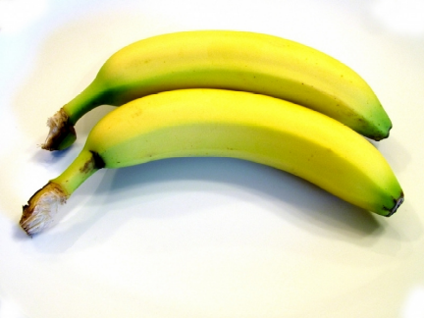
Outfield soccer players can use up 200 to 250 grams of carbohydrates during a game. It’s important that they replenish those stores as quickly as possible. It becomes even more important if players have more than one match in the week or are involved in heavy training.

Ideally a large, high-carbohydrate meal should be eaten within two hours and it can and should consist of high GI foods. Bananas and dried fruits are good immediately following a match, as are sandwiches and high-carbohydrate drinks like Gatorade Exceed and Lucozade. A main meal several hours later might consist of bread, pasta, potatoes and rice as well as other simple sugars like cakes and sweets.

Even under the best circumstances it can take over twenty hours to fully
restore carbohydrate stores. This has implications for players who are
training five or six days a week. In this case carbohydrate replenishment at
regular intervals during training sessions becomes important. This is where
high-carbohydrate drinks can offer a real advantage.

